

**Mehran University of Engineering & Technology, Jamshoro**

**Department of Software Engineering**

**MAD CEP – Mobile Application**

|  |  |
| --- | --- |
| **Name:** | Abdul Kabeer,  Ahmed Nadeem |
| **Roll no:** | 22SW067,  22SW134 |
| **Project:** | TextHub (Chatting Application) |
| **Subject:** | MAD Project Report |
| **Submitted to:** | Ma’am Mariam Javed |

**1. Real World Problem Identification**

In today’s fast-paced digital world, instant communication is essential for collaboration and connectivity.  
While popular chat platforms exist, many developers and organizations require a **customizable, private, and educational chat system** to understand how messaging apps work internally.

A need was identified for a **simple, real-time chat app** that demonstrates:

* Firebase integration for authentication and data handling
* Responsive and gesture-based UI design
* Secure user sessions and logout
* Clean and scalable code architecture using Flutter

**2. Proposed Solution**

To meet this need, we developed **TextHub**, a modern chat application built using **Flutter** and **Firebase**.

TextHub enables users to:

* Register and log in securely using Firebase Authentication
* Send and receive messages instantly using Firebase Firestore
* Experience smooth navigation with gesture
* Use a clean, minimal, and responsive Material UI

**Key Features:**

* Firebase Authentication (Email & Password)
* Real-time Firestore Messaging
* Drawer-based Navigation
* Secure Logout and Session Handling
* Responsive UI supporting multiple screen sizes

**3. Responsive User Interfaces**

TextHub’s interface was designed using Flutter’s **responsive widgets**, ensuring smooth performance on different screen sizes and orientations.

**Supported Platforms:**

* Android
* Web

🖼️ **Screenshots:**

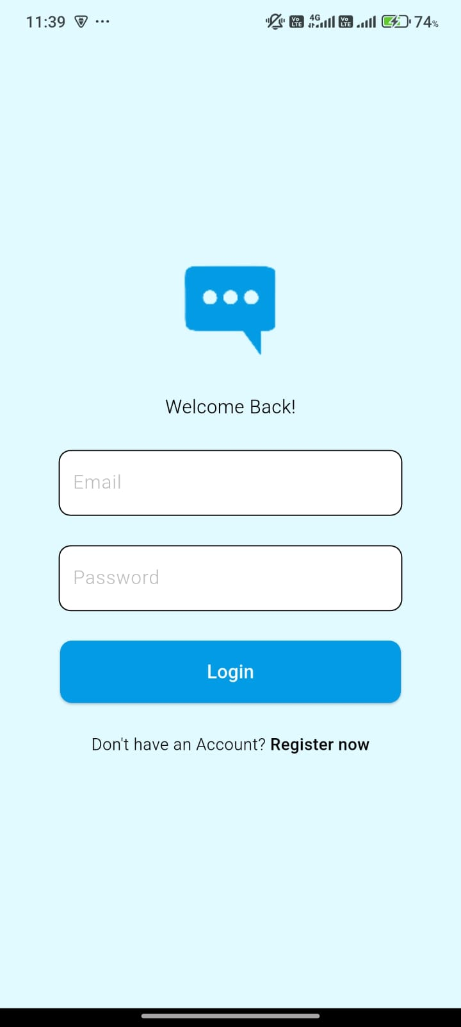

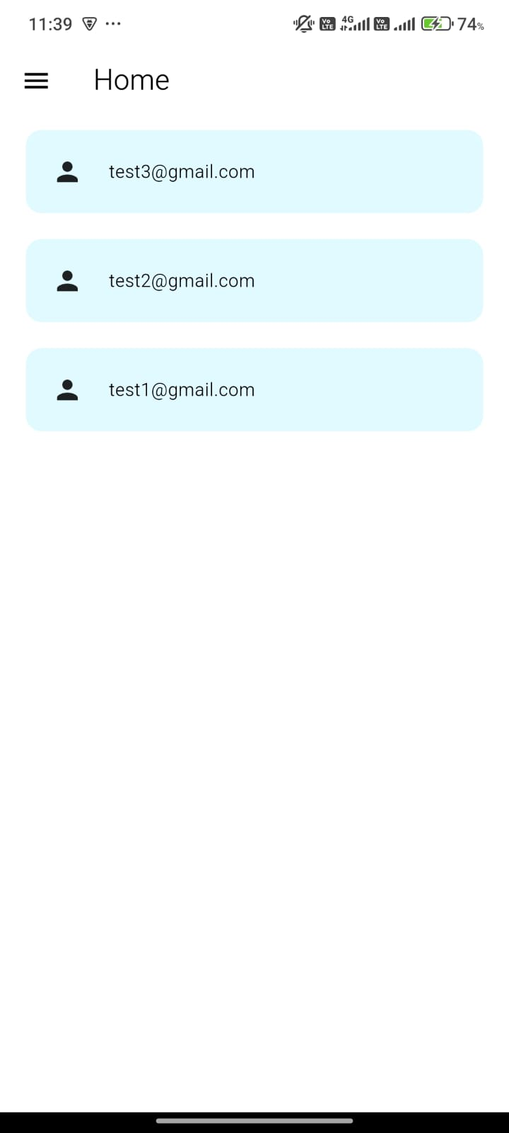 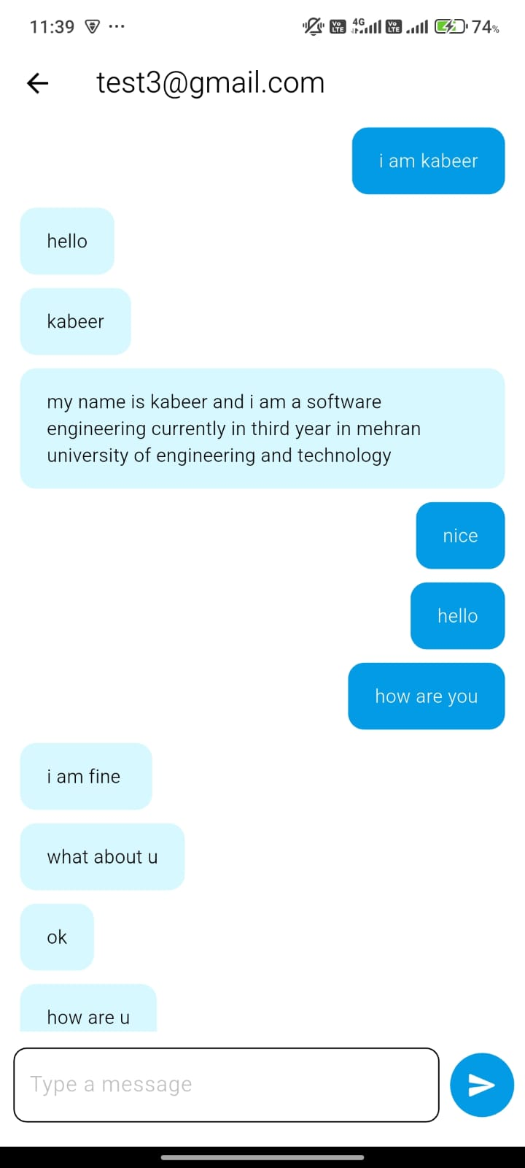

**4. Data Storage**

**Database Used:** Firebase Firestore

**Justification for Using Firebase Firestore**

🔥 **Real-time Communication:**  
Firestore’s live snapshot feature ensures that messages appear instantly across all connected users.

☁️ **Cloud-based Storage:**  
All chat data is stored securely in Firebase’s cloud infrastructure.

🔐 **Integration with Authentication:**  
Each user’s messages can be linked to their Firebase UID for identity and session management.

⚙️ **Scalability:**  
Automatically scales to handle multiple users and messages without extra backend setup.

**Why Not Local Databases (e.g., Hive or SQLite):**

* They don’t support real-time synchronization across devices.
* Firestore allows multi-user communication through the cloud, which local databases cannot achieve.

**5. APIs / Packages / Plug-ins Used**

| **Package / Plug-in** | **Purpose** | **Justification** |
| --- | --- | --- |
| **firebase_core** | Initializes Firebase in the Flutter app | Required for connecting the app to Firebase services (Auth, Firestore, etc.) |
| **firebase_auth** | Handles user login and registration | Provides secure, ready-to-use authentication with email & password |
| **cloud_firestore** | Stores and retrieves chat messages in real time | Enables instant updates for messages using real-time listeners |
| **flutter/material.dart** | UI framework | Used for building responsive and modern Material Design interfaces |
| **google_fonts** *(if used)* | Adds custom font styles | Enhances the app’s visual design and readability |

**6. Issues and Bugs Encountered and Resolved**

**Error:  
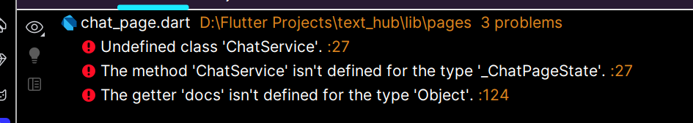**

**Solution:**

**import 'package:text_hub/services/chat/chat_service.dart';**

**Solution:**

Define the signInWithEmailAndPassword in AuthService file

**Error:**

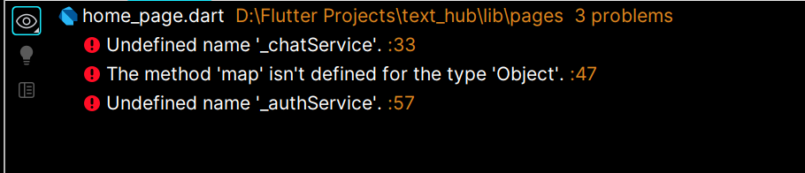

**Solution:**

I didn’t created object of _chatService and _authService

**final ChatService _chatService= ChatService();  
final AuthService _authService= AuthService();**

**Error:**

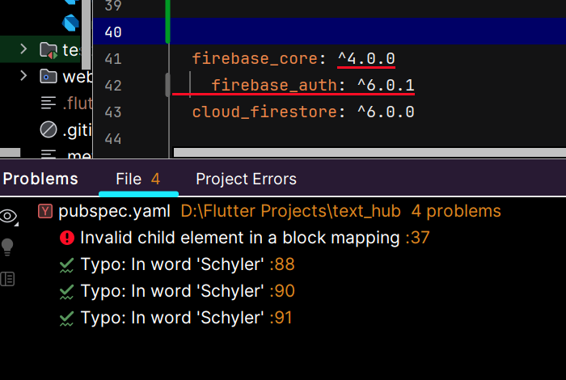

**Solution:**Flutter follow proper indentation ,so here all three dependencies should be aligned.

**Error:**

I faced issue when tried to connect Firestore with flutter project

**Solution:**

I did not download google-services. Json due to which I faced problems.

**Error:**

I also faced issues in **Login/Register** due to invalid input

**Solution:**

I applied Input Validation Logic to ensure that user inputs correct data.

After resolving these issues, TextHub now provides a stable and seamless real-time chat experience.

**7. Conclusion**

TextHub demonstrates how **Flutter** and **Firebase** can be used to build a responsive, real-time chat system with minimal backend configuration.  
The app successfully integrates **authentication, messaging, and clean UI design** — making it ideal for learning and small-scale real-world use cases.